**ONLINE PIZZA SHOP**

**SECOND REVIEW**

**GUIDE** **Group members**

MRS.RAJALAKSHMI K.R ANANTHU SURESH

ABHIJITH P.R

BLESSIN MATHEW

ABHIJITH ANIL

ELDHO M.S

**CONTENT**

**INTRODUCTION 3**

**MODULES 3-4**

**DATABASE DESIGN 4-6**

**DATA FLOW DIAGRAM 7-9**

**CONCLUSION 10**

**REFERENCE 10**

**INTRODUCTION**

Now a days people feels uncomfortable to visit crowded markets. So we developed our online pizza shop.The main aim of this project is to change the existing system of food shopping.The central concept of this application is to allow the customers to shop virtually through internet. In existing system all works are done manually so it has many disadvantages. So we designed our database and DFD to understand and study the system.

**MODULES**

Online Pizza shop deals with mainly two modules and they are:

1: ADMINISTRATION

2: USER MANAGEMENT

ADMINISTRATION

Administrator is the super user of the system.The admin can add new dishes into the system, view sales report & order summary and also manages the registered user details in the system.

SUBMODULES:

Product Management

This module deals with the addition of new products or dishes, product price etc into the system, these are also managed by the admin of the system.

Delivery Management

This module deals with managing the order, approving & view order details which are handled by the admin of the system.Also the admin can read feedbacks and suggestions send by the customers . It helps improving the entire system. Also we can upgrade the system with consideration of customer suggestions

USER MANAGEMENT

A user must register into the system inorder to place the order. A new user can easily signup into the system with their unique username and password . After registration they can perform different tasks which is guided by admin.

SUBMODULES:

Order Management

User can add products to cart , delete from cart etc. Cart is very helpful for bulk orders that we can place different types of food products in a single order. Cart is simply a knapsack

User can also track their order after placing. The pizza will be delivered by delivery staffs. User can frequently check the status of order with our project

Feedback

With help of this module customers can send feedbacks or suggestions to the shop regarding delivery time,food quality, packaging etc. Admin will take care of this later.

**DATABASE DESIGN**

A database is a collection of information that is organized so that it can be easily accessed, managed and updated. We use Mysql for building our database. And these are our tables:

Adminlogin

|  |  |  |  |
| --- | --- | --- | --- |
| Field Name | Data type | Constraints | Description |
| adname | Varchar (20) | Primary Key | Unique Username of admin |
| adpass | Varchar (20) | Not Null | Password of admin |

Categories

|  |  |  |  |
| --- | --- | --- | --- |
| Field Name | Datatype | Constraints | Description |
| catid | Int | Primary Key | Unique id for each category |
| catname | Varchar (20) | Not Null | Name for each category |
| catimg | Varchar (40) | Not Null | Image,describing details |

Products

|  |  |  |  |
| --- | --- | --- | --- |
| Field Name | Datatype | Constraints | Description |
| pid | Int | Primary Key | Unique id for each product. |
| catid | Int | Foreign Key |  |
| pname | Varchar(20) | Not Null | Name of product. |
| Price | Float | Not Null | Price for each quantity |
| pimg | Varchar(20) | Not Null | Image of product |
| details | Varchar(15) | Not Null | Availability of Product. |

Customerdetails

|  |  |  |  |
| --- | --- | --- | --- |
| Field Name | Data Type | Constraints | Description |
| cid | Int | Primary key | Unique id of customer. |
| Username | Varchar(20) | Unique,Not Null | Unique name of the user |
| Cname | Varchar(20) | Not null | fullname of the customer |
| phone | Int | Not null | Contact number of Customer. |
| cpass | Varchar(20) | Not Null | password of customer |

Orders

|  |  |  |  |
| --- | --- | --- | --- |
| Field name | Data type | Constraints | Description |
| oid | Int | Primary key | Unique id for orders |
| cid | Int | Foreign key | Customer ID |
| Dod | Date | Not Null | Date of purchase |
| total | Int | Not Null | Total Amount |

Orderdetails

|  |  |  |  |
| --- | --- | --- | --- |
| Field name | Data type | Constraints | Description |
| pid | Int | Foreign key | Product ID |
| oid | Int | Foreign key | Order ID |
| quantity | Int | Not null | Quantity Of Product |
| price | Float | Not null | Rate Of Product |
| Status | Varchar (20) | Not null | Status of the order |
| Size | Int | Not null | Size of the pizza |

Delivery Details

|  |  |  |  |
| --- | --- | --- | --- |
| Field name | Data type | Constraints | Description |
| did | Int | Primary Key | Delivery ID |
| oid | Int | Foreign Key | Order id |
| Dname | Varchar(20) | Not Null | Name of the person receiving order |
| pin | Int | Not Null | Pin Code of customer |
| hno | Varchar (20) | Not Null | Address of customer |
| city | Varchar (20) | Not Null | Address of customer |
| landmark | Varchar (20) | Not Null | Address of customer |

Feedback

|  |  |  |  |
| --- | --- | --- | --- |
| Field Name | Datatype | Constraints | Description |
| fid | Int | Primary Key | ID for feedback |
| oid | Int | Foreign key | Order id |
| feedback | Varchar(300) | Not Null | Body of feedback |

**DATA FLOW DIAGRAM**

A data-flow diagram is a way of representing a flow of data through a process or a system (usually an information system). The DFD also provides information about the outputs and inputs of each entity and the process itself

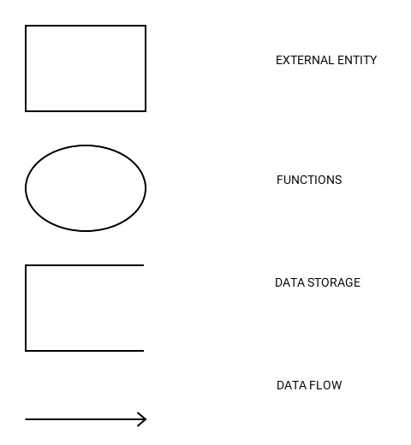**DFD SYMBOLS**

**CONTEXT DIAGRAM**

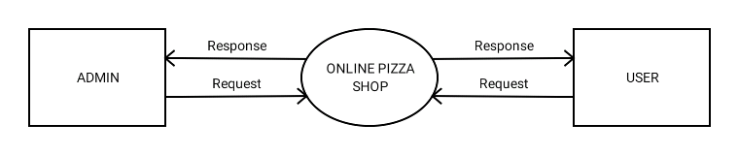

**1st LEVEL DFD FOR ADMINISTRATION**

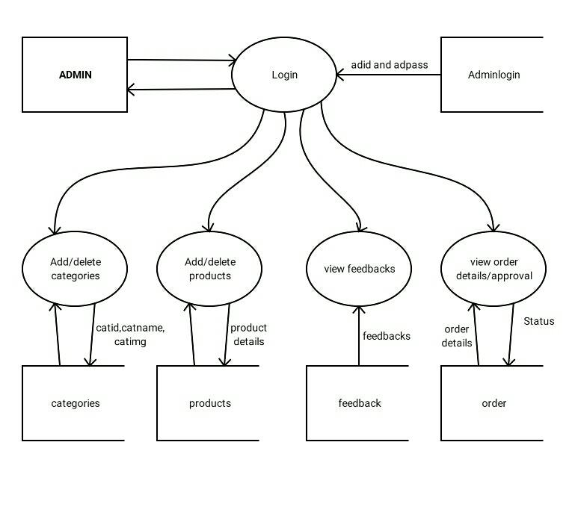

**1st LEVEL DFD FOR USER MANAGEMENT**

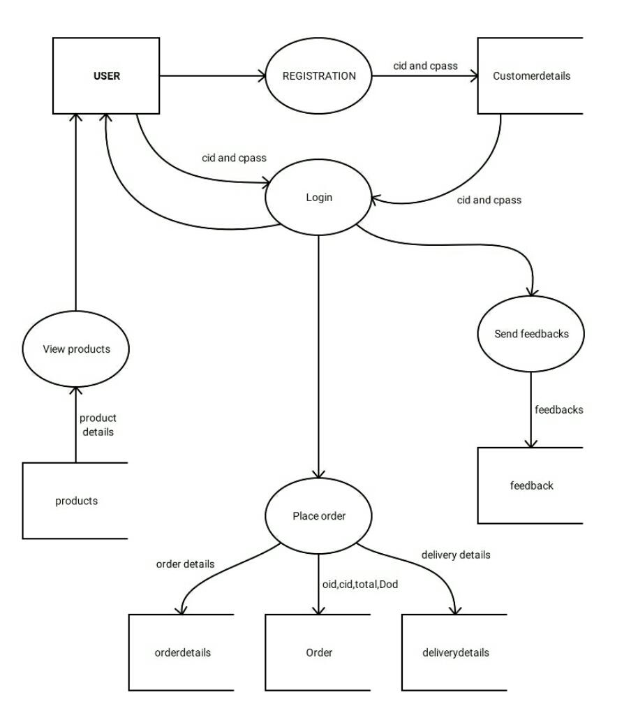

**CONCLUSION**

We developed an application for online pizza shop. This is easily accessible,informative and helpful. User can select and order pizza through our project.This project is designed with much care free of errors, efficient, accuracy etc.Our system is user friendly and simple.It is also upgradable in future.Our Database is well managed and maintained.

**REFERENCE**

* Database design concept(Henry korth)
* Software Engineering (K.K Aggarwal and Yogesh Singh)
* System analysis and design (Elias M award)
* https://www.freeprojectz.com